SSC Xmas Charity Event
Open Doubles Tournament
Saturday 2nd December 2017
@ 3:00pm
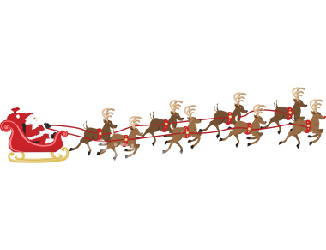
You are invited to participate in a doubles handicap tournament on the above date.
Please pick your partner & enter now
If you would like to play but do not have a partner please enter & we will pick someone for you.
Entry fee £5.00 per person
Closing date for entries17th November 2017
We will be collecting money for the NSPCC, which is David Exley chosen Charity
Please be generous with your donation
Food: Choice of Chinese or Indian take-away will be available.
Money and order will be collected nearer the time
Menu behind the bar.
If you are interested please put your name down on the list provided behind the bar or on the Gym window.

Let’s make this a fun night !!!!!!

