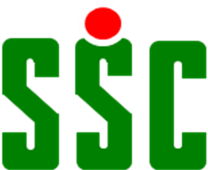

“MEMBER GET MEMBER” PROMOTION.

Storrington Squash Club have a new membership reward scheme whereby members who introduce a new adult playing member (£280 subscription rate) will be entitled to receive a voucher for £30.

This voucher may be redeemed as cash, be used for purchases in the shop or for paying behind the bar.

For further details please contact Dany or Simon.

